FINAL TECHNICAL REPORT SUBMISSION FOR LEVEL-III “PROTOTYPE” OF ROBOFEST-GUJARAT 4.0

1.Description of Robot
The maze solver robot is a compact and sophisticated device designed for autonomous navigation throughout the complex path. It features high-encoder motors (N20 encoder motor) with specified rpm and wheels that ensure smooth and agile movement. Equipped with advanced Time of Flight (TOF) sensors (VL53LOX, VL6180X), that effectively detect obstacles and walls by transmitting and receiving infrared rays, enabling it to navigate with precision. A dedicated motor driver (TB6612FNG) controls these motors, allowing for precise speed and direction adjustments based on real-time data received from the TOF sensors. At its core is a powerful microcontroller (STM32 Blue Pill) that processes data from these sensors and determines efficient routes based on the algorithm. The robot’s design and programmed algorithm allows the bot to explore the maze completely and find the shortest path to reach the target. Powered by rechargeable batteries, the robot is not only efficient but also environmentally friendly, making it ideal for extended exploration missions.

2.Salient Features of Robot
2.1: Autonomous Navigation:
Maze-solving robots utilize sensors and algorithms to navigate without human intervention. They analyze the maze layout in real-time to determine the optimal path. Advanced programming enables them to adapt to obstacles and dead ends. These robots showcase precision and efficiency in autonomous decision-making.

2.2: Short Path Detector:
The short path detector enables the robot to identify and choose the quickest route to the destination. Using algorithms like Dijkstra or A*, it analyzes multiple paths and calculates the shortest one. Sensors provide real-time data for accurate decision-making. This feature ensures efficient and time-saving navigation through the maze.

2.3: Real-time data Processing:
Real-time data processing allows the robot to adapt dynamically to the maze environment. Sensors continuously collect data on obstacles and paths, which is instantly analyzed by the robot's controller. This enables quick decision-making for navigation and avoiding dead ends. It ensures accurate and efficient performance in unpredictable maze layouts.

2.4:Obstacle Avoidance:
Obstacle avoidance ensures the robot detects and navigates around obstacles in the maze. Sensors like ultrasonic or infrared provide real-time feedback on object proximity. The robot processes this data to alter its path and avoid collisions. This feature enhances the robot's efficiency and adaptability in complex environments.

2.5 Adaptive Decision-Making:
Adaptive decision-making enables the robot to adjust its actions based on real-time maze conditions. It analyzes sensor data to identify paths, dead ends, or obstacles and modifies its route accordingly. This dynamic approach allows the robot to handle unexpected changes effectively. It ensures efficient navigation through unpredictable maze layouts.

3.Description of Mechanical Design
The mechanical design of a micro mouse robot refers to the physical structure, components, and arrangement that enable the robot to navigate a maze autonomously. It involves selecting materials, ensuring structural integrity, and integrating various mechanical and electrical components in a compact and functional form. Here’s a detailed description of the mechanical design process:

3.1 CAD Modelling
- CAD Modeling: Using Computer-Aided Design (CAD) software to create detailed 3D models of the robot, including the chassis, wheels, and sensor mounts.
- Component Selection: Choose appropriate materials and components (motors, sensors, batteries) based on performance requirements and weight considerations.

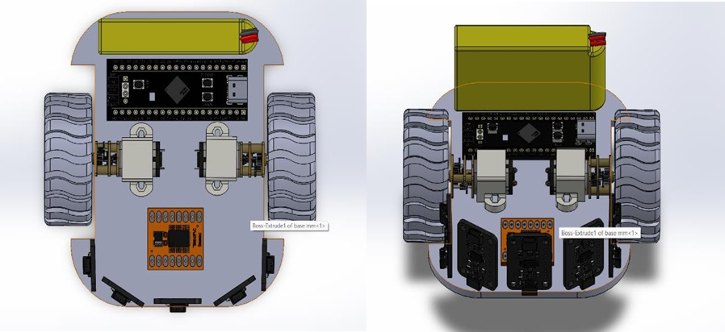
Figure 1. CAD Model of Bot

3.2 Printed Circuit Board (PCB)
The PCB or frame is the main body of the robot, where all components are mounted. It provides structural support and determines the overall shape and size of the robot.

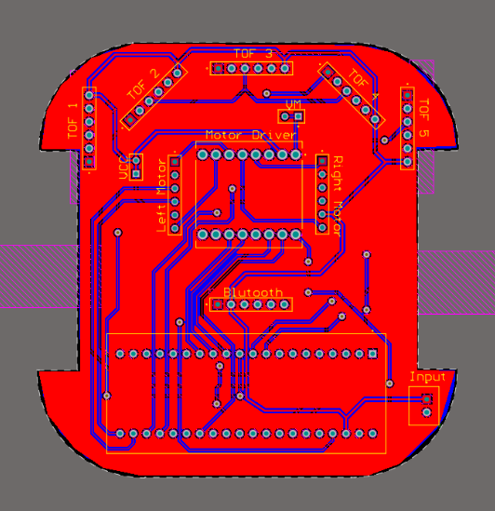
Figure 2. PCB Top Layer Design
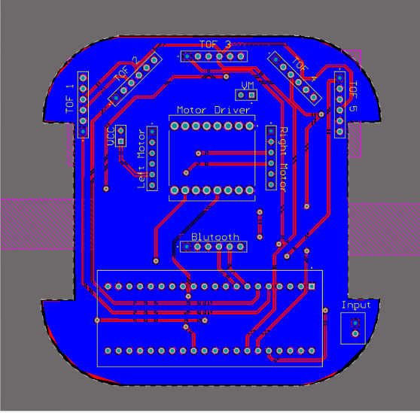
Figure 3. PCB Bottom Layer Design

3.3 Motor and Wheel System
The robot’s movement relies on a motor-driven wheel system that provides both mobility and maneuverability.
- Motors: Typically DC motors are used because they are simple,efficient, and provide the necessary torque.
- Motor Mounting: Motors are mounted onto the PCB using dedicated slots or brackets. These mountings need to be secure to prevent movement or misalignment during operation.
- Wheels: The wheels are attached to the motors to allow the robot to move. The wheels need to be small but have sufficient traction to move on the maze floor.
- Wheel Placement: The wheels are positioned at the robot’s center for optimal balance and movement.
- Differential Drive: Most micro mouse robots use a differential drive system, where two or more wheels are powered independently to provide steering control.

3.3 Sensor System
The sensors are crucial for detecting walls, obstacles, and the robot’s position within the maze. The placement of sensors is critical to ensure accurate environment perception.
1.Detect Obstacles and Walls: Strategically positioned sensors provide data from multiple directions (front, sides, etc.), enabling the robot to navigate effectively.
2.Avoid Dead Zones: Proper placement ensures no area around the robot is left undetected, avoiding blind spots that could hinder performance.
3.Efficient Navigation: Sensors at key points help the robot make accurate decisions for movement, such as turning, stopping, or adjusting its path.
4.Structural Stability: Mounting sensors on the PCB ensures they remain fixed and aligned during operation, providing consistent and reliable readings.

3.4 Power System
The power system includes the battery and the power distribution network that supplies energy to the robot's components (motors, sensors, microcontroller, etc.).
1.Battery Selection: Lithium-polymer (LiPo) batteries are used due to their high energy density and small size.
2.Power Distribution: The robot requires a power distribution system that channels the correct voltage to each component.

3.Battery Placement: The battery is placed in the rear of the PCB that maintains the robot’s balance.

3.5 Mounting and Assembly
The assembly involves integrating all the components (motors, wheels, sensors, microcontroller, and battery) into the PCB. Proper mounting is crucial to maintain the structural integrity and ensure that components are securely fastened.
Mounting Points:
- Holes or slots are created in the PCB to securely mount each component, ensuring that there is no movement or vibration during operation.
- .For motors, precise motor mounts are designed to hold the motors in place without flexing.
- Sensors are mounted on adjustable arms or slots for fine-tuning their positions.
Space Optimization:
The robot’s internal space should be organized to keep wiring and components as compact and secure as possible. This is critical for minimizing weight and ensuring stability.

3.6 Control System and Microcontroller Integration
The control system consists of the microcontroller, which processes inputs from sensors, computes the robot's decisions, and sends commands to the motors. Microcontroller Placement: The microcontroller STM32 is placed in the rear of the PCB.
- Wiring and Connectors: Wires are connected and kept away from rotating parts, and connectors should be chosen to prevent disconnections during movement.
- PCB as Structural Element: In some designs, the PCB serves as both the structural base and the circuit carrier. Components like motors, sensors, and the microcontroller are mounted directly onto the PCB, reducing the need for additional framing.
4. Description of all the logical steps in the working of mechanical design.
1. Objectives and Requirements
1.Identify Goals: Determine the primary objectives of the micromouse robot, such as speed, accuracy, and maze-solving capabilities.

2.Set Specifications: Establish size constraints, weight limits, and performance metrics (e.g., maximum speed, turning radius).

2. Chassis Design
- Structural Analysis: Analyze the chassis design for strength and stability, ensuring it can withstand operational stresses.
- Weight Distribution: Optimize the layout to achieve a low center of gravity, enhancing stability during movement.

3.Drive System Design
- Motor Configuration: Decide on the type and configuration of motors (e.g., stepper or DC motors) and their placement on the chassis.
- Wheel Design: Design wheels with appropriate diameter and tread patterns for traction and maneuverability.

4. Sensor Integration
- Sensor Selection: Choose sensors based on the required detection range and accuracy (e.g., IR sensors for line detection, ultrasonic sensors for distance measurement).
- Placement Strategy: Determine optimal sensor placement to maximize coverage and minimize blind spots, ensuring effective obstacle detection.

5. Power Supply Design
- Battery Selection: Choose a suitable battery type (e.g., LiPo, NiMH) based on voltage and capacity requirements
- .Power Distribution: Design a power distribution system to efficiently supply power to motors and sensors, minimizing voltage drops.

6. Control System Design
- Microcontroller Selection: Choose a microcontroller that meets processing and input/output requirements for controlling motors and sensors.
- Circuit Design: Create a schematic for the control circuitry, including connections for motors, sensors, and power supply.

7. Prototyping
- 3D Printing: Fabricate a prototype of the chassis and other components using 3D printing to test fit and functionality.
- Assembly: Assemble the prototype, integrating all components to evaluate the overall design.
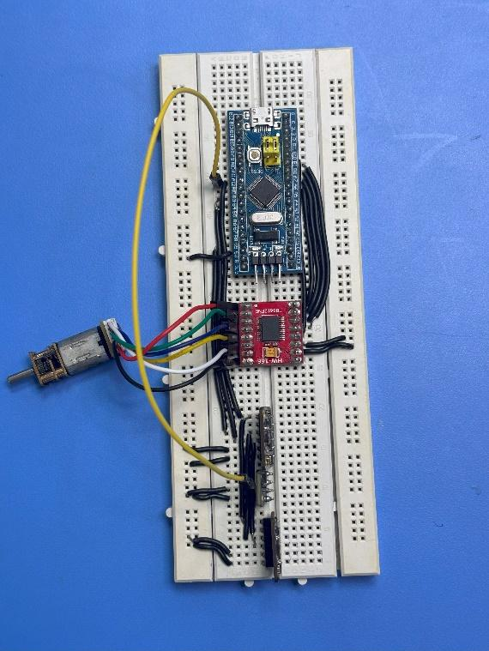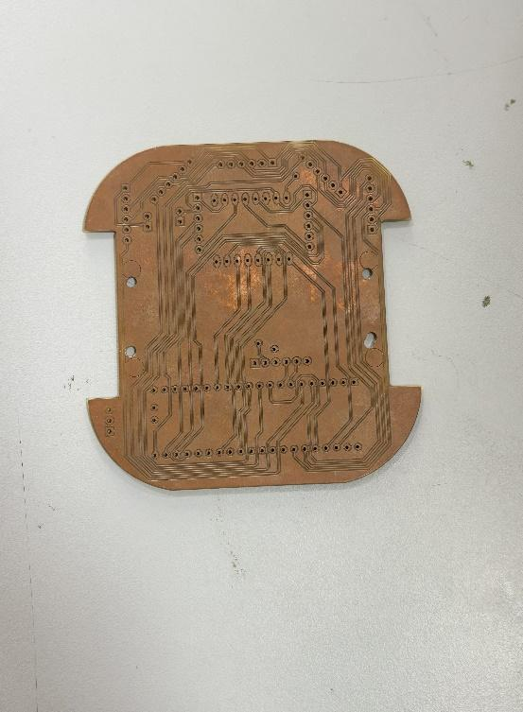
Figure 4. Breadboard Connection Figure 5. Single Layer PCB
8. Testing and Iteration
- Initial Testing: Conduct tests to evaluate the robot's performance in navigating a maze, checking for issues such as st
- ability, speed, and sensor accuracy.Data Analysis: Analyze test results to identify areas for improvement, such as adjustments to weight distribution or sensor calibration.
- Iterative Design: Refine the design based on testing feedback, making necessary modifications to improve performance.
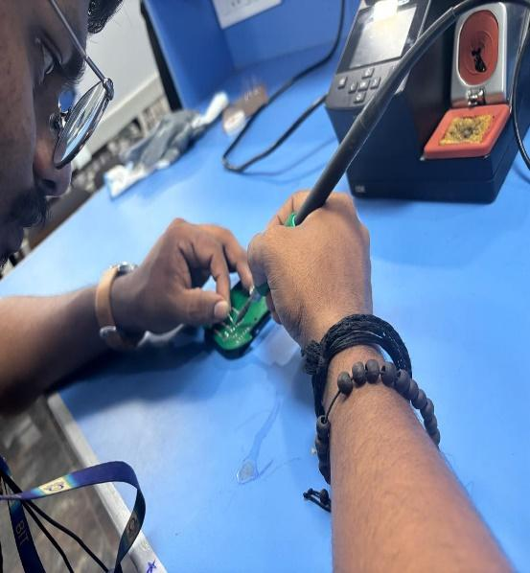
Figure 6. Soldering Components

9. Final Fabrication
- Material Selection: Choose final materials for the production version based on durability and weight considerations.
- Manufacturing: Fabricate the final components using selected manufacturing techniques (e.g., CNC machining, injection molding).
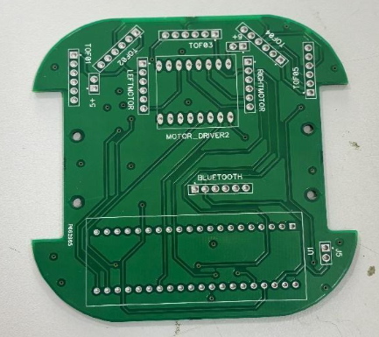
Figure 7. PCB Double Layer after fabrication

10. Final Assembly
- 1.Component Integration: Assemble the final components, ensuring all parts fit correctly and securely.
- Wiring and Connections: Make electrical connections, ensuring proper routing of wires to avoid interference and damage.
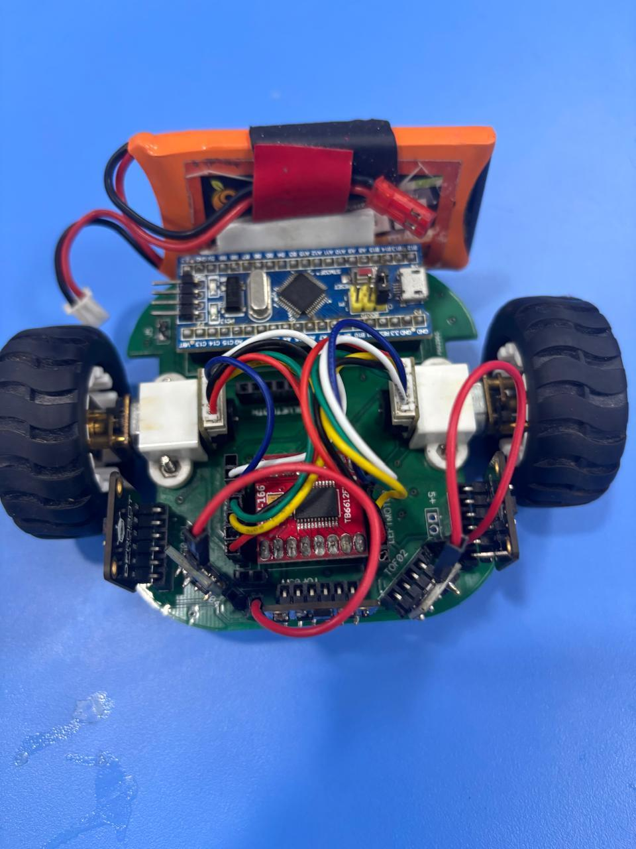
Figure 8. Assembled Bot

11. Calibration and Fine-Tuning
- Sensor Calibration: Calibrate sensors to ensure accurate readings and responsiveness..
- Motor Tuning: Adjust motor settings (e.g., speed, acceleration) to optimize performance during maze navigation.
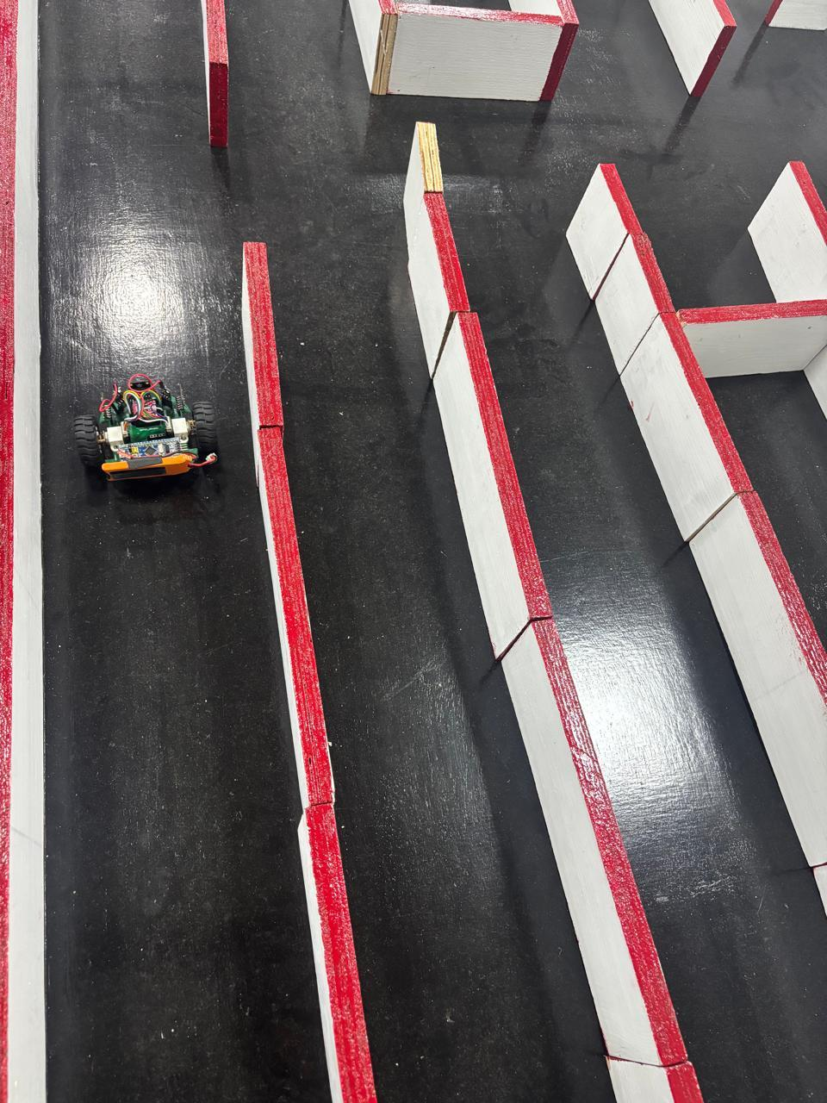
Figure 9. Bot Working
5.Software used for Robot-Making.

- Altium Designer
Altium Designer is a powerful PCB design software essential for developing maze solver robots, offering a comprehensive suite of tools to streamline the design process. Its intuitive interface allows engineers to create detailed schematics and complex circuit layouts while integrating various components like sensors, motors, and microcontrollers.
Key features include advanced routing capabilities, such as interactive routing and auto-router functionality, which optimize layouts for size and performance. The software includes robust design rule checking (DRC) to identify potential manufacturing issues, reducing errors. With its 3D visualization feature, users can assess component placement and wiring space effectively.
Altium also facilitates collaboration through project management tools and version control, enhancing teamwork. Additionally, it generates critical manufacturing outputs, such as Gerber files and bills of materials (BOM), ensuring a smooth transition from design to production. Overall, Altium Designer improves the efficiency and accuracy of maze solver robot projects.

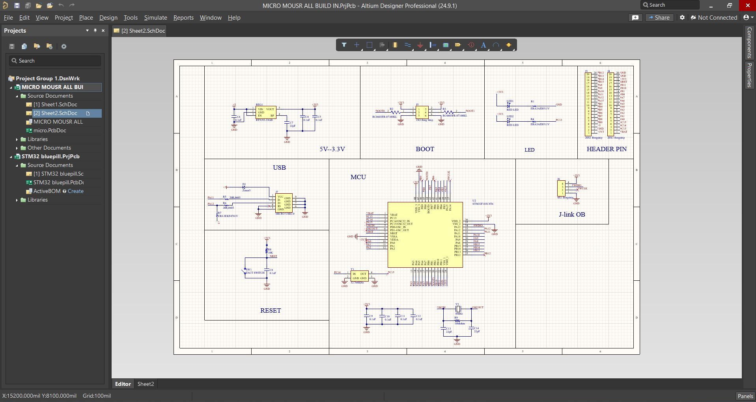
Figure 10. Schematic Design in Altium

- ARDUINO IDE

The Arduino IDE (Integrated Development Environment) is a powerful and user-friendly platform designed for programming Arduino boards, making it ideal for projects like maze solver robots. Its simple interface caters to both beginners and experienced developers, featuring syntax highlighting and code auto-completion to enhance the coding experience. With extensive library support, users can easily integrate components like sensors and motors, speeding up development.
Cross-platform compatible with Windows, macOS, and Linux, the Arduino IDE allows coding and uploading on various operating systems. The built-in serial monitor enables real-time communication with the Arduino board, aiding in debugging and monitoring during operation. Supported by a vast community offering documentation, tutorials, and forums, the Arduino IDE simplifies the coding, testing, and optimization of navigation algorithms for robotics projects. Overall, it is an essential tool for developing maze solver robots efficiently.

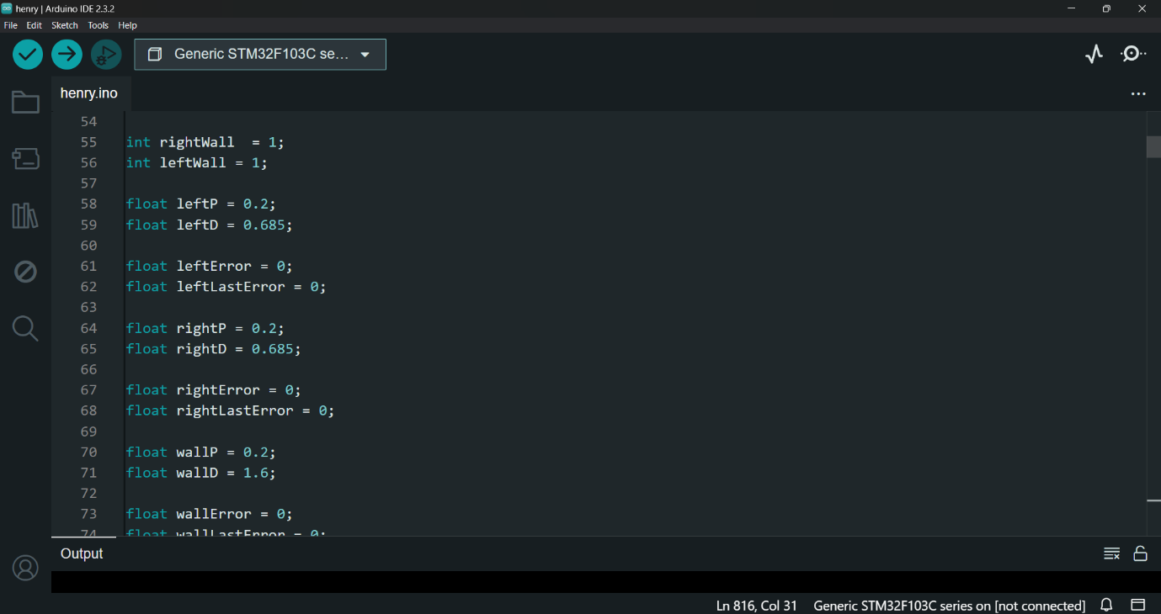
Figure 11. Bot Coding

- SOLID WORKS:

SolidWorks is a leading computer-aided design (CAD) software developed by Dassault Systems, widely utilized in engineering and manufacturing for 3D modeling, simulation, and product design. It enables users to create detailed 3D models of parts and assemblies with a parametric design feature that automatically updates related dimensions when changes are made. The software also includes robust simulation tools, allowing for testing under real-world conditions, such as stress analysis and motion dynamics. Additionally, SolidWorks facilitates the generation of 2D drawings from 3D models, making it easier to create technical documentation. With its ability to manage complex assemblies, collaborate through cloud services, and customize functionalities with add-ins and macros, SolidWorks is essential for professionals across various industries, including aerospace, automotive, and consumer products. Its user-friendly interface makes it accessible to both beginners and experienced users, providing the necessary tools to transform innovative ideas into tangible designs.

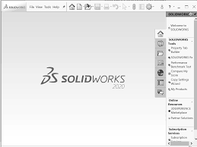

Figure 12. Designing in Solid Works

- DIPTRACE
Dip Trace is a versatile PCB design software suitable for both novice and experienced engineers, making it ideal for projects like maze solver robots. It provides a comprehensive suite of tools for schematic capture, PCB layout, and manufacturing output, streamlining the design process. The user-friendly interface allows easy creation and editing of schematics with a vast library of symbols and footprints.
Supporting multi-layer designs, DipTrace features powerful routing tools, including auto-routing and manual routing, along with design rule checking (DRC) to ensure compliance with standards. Its 3D visualization capability enables users to identify potential issues with component placement before manufacturing. Dip Trace also generates essential manufacturing files, such as Gerber files and bills of materials (BOM), simplifying the transition from design to production. With robust import and export capabilities, it integrates seamlessly with other design tools, making it a valuable asset for creating PCBs for maze solver robots and other electronic projects.

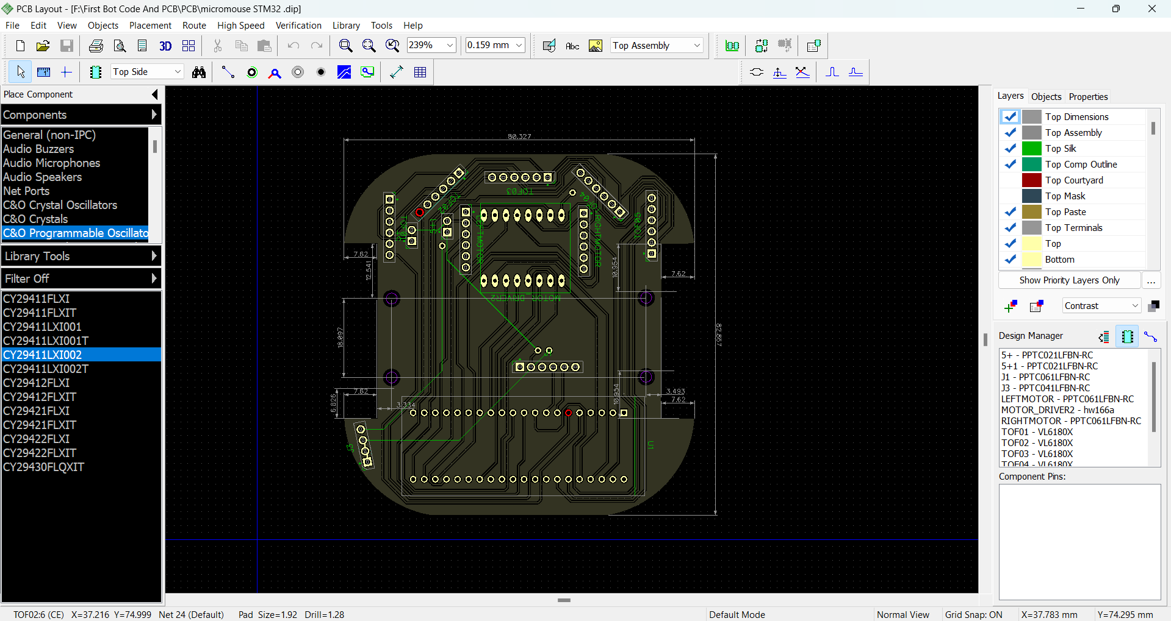
Figure 13. Single Layer Routing in Diptrace

6.Details of the Manufacturing / Fabrication of the Mechanical Assembly
Using a PCB (Printed Circuit Board) for the mechanical strength in the design of a micro mouse robot is an excellent approach, particularly for compact robots. While PCB boards are primarily used for electrical connections and circuit routing, they can also serve as a structural component in certain designs, offering benefits in terms of both strength and integration. Below are the key logical steps to integrate a PCB into the mechanical design of your micro mouse robot:
6.1.PCB Board as Base:
- The PCB acts as the primary structural chassis, supporting all components, including motors, sensors, and the microcontroller.
- Its compact and sturdy design ensures stability and lightweight operation.

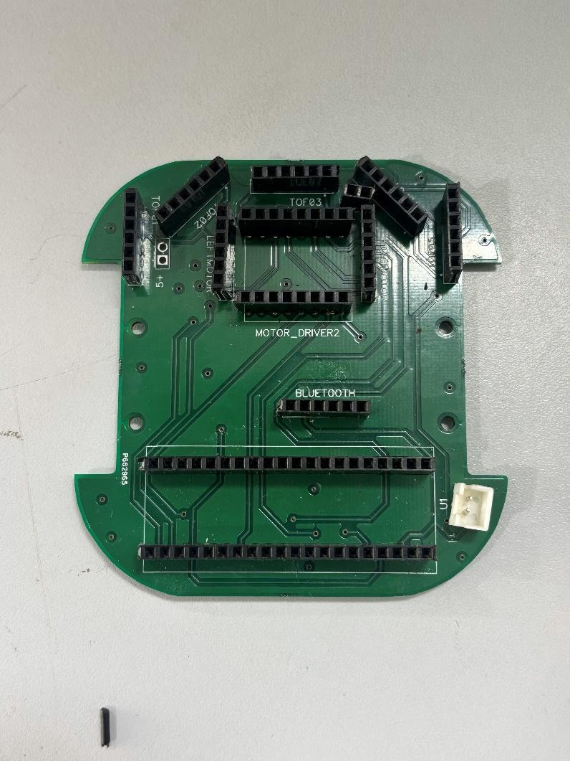
Figure 14. Double Layer PCB Base

6.2.Differential Drive Mechanism:
- The N20 encoder motors drive the wheels independently, allowing precise movements such as forward motion, backward motion, and turns.
- The placement ensures efficient power transfer to the wheels for smooth navigation.

6.3.Wheel Alignment and Movement:
- Wheels are mounted directly to the motors with a symmetrical setup for balanced motion.
- The design ensures proper traction and stability, even during sharp turns.

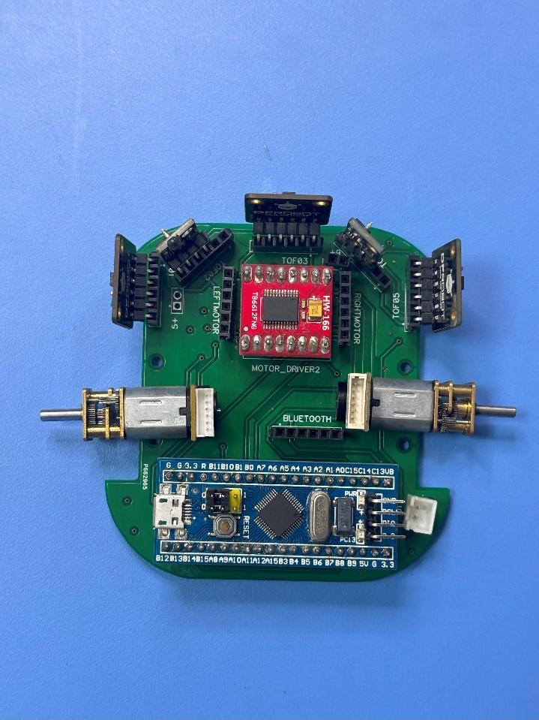
Figure 15. Component Placement

6.4.Sensor Mounting:

- TOF sensors are mounted on the PCB at the front and sides using header pins,providing strategic placement for effective obstacle detection and navigation.
- The placement maximizes coverage for real-time adjustments in movement.

6.5.Battery Positioning and Weight Distribution:
- The battery is mounted on top, ensuring proper weight balance to prevent tipping or instability during movement.
- The position optimizes the center of gravity for stable navigation.

6.6.Connection and Wiring:
- All components are interconnected with neatly routed wires to avoid tangling or interference with mechanical operations.Proper connectors and header pins ensure durability and ease of maintenance.
- This design ensures a reliable and efficient mechanical framework, enabling the robot to navigate complex mazes effectively.

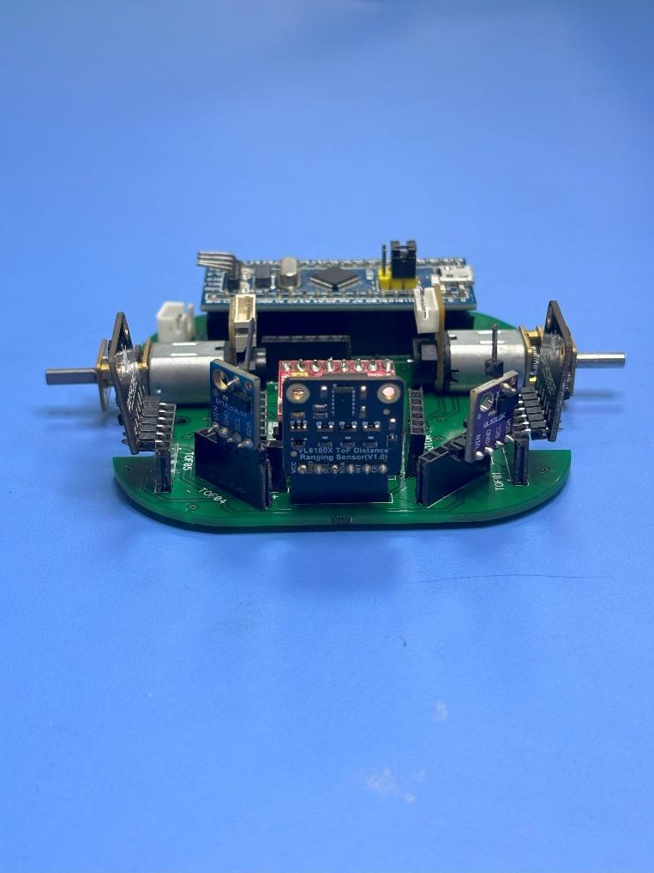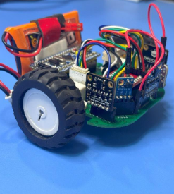
Figure 16. Boot Front View and Wire Connection

7.Electronic Components and their Working.

S.No. | Components | Working
1 | Sensor (TOF) | Measure distances to detect obstacles and aid in navigation.
2 | Motor Driver | Controls the speed and direction of motors based on microcontroller commands.
3 | Motor | Processes sensor data, implements maze-solving logic, and controls all components.
4 | Microcontroller | Provides real-time speed and position feedback for accurate motion control.

8.Description of all the logical steps in the working of electronic components.

1. TOF Sensor (VL6180X & VL53L0X)

Logic:
Time-of-Flight (ToF) is the fundamental principle:
  - Emits light (infrared or laser).
  - Measures the time taken for the light to hit an object and return to the sensor.
  - Calculates distance using the formula:
Distance = ( Speed of Light * Time of Flight ) / 2
Provides real-time distance readings to detect obstacles or measure proximity.
Logic is used to determine path decisions based on object detection.

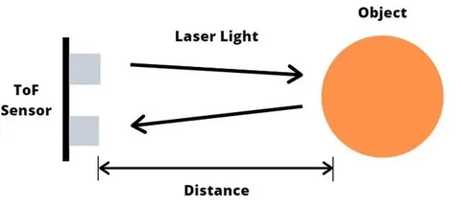
Figure 17. Sensor Working

2. TB6612FNG Motor Driver
Logic:
- Motor Control:
  - Uses input signals (IN1, IN2) from the microcontroller to control motor direction:
    - Forward: IN1 = HIGH, IN2 = LOW.
    - Reverse: IN1 = LOW, IN2 = HIGH.
    - Brake: Both signals are LOW.
  - Adjusts motor speed using PWM signals from the microcontroller.
- Allows the robot to move forward, backward, or turn by controlling two motors independently.

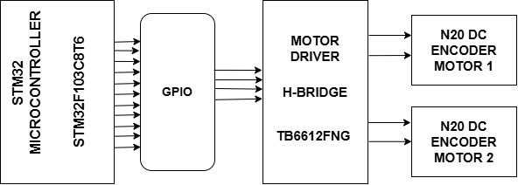
Figure 18. Motor Connection Block Diagram

3. STM32 Microcontroller

Logic:
- Acts as the central controller to integrate all components:
  - Sensor Data Processing:
    - Reads ToF sensor data to detect obstacles and measure distances.
  - Motor Control:
    - Sends direction and speed commands (via PWM) to the motor driver based on the robot's movement requirements.
  - Decision-Making:
    - Implements algorithms (e.g., Flood Fill, A*, etc.) to solve the maze by analyzing sensor data and encoder feedback.
  - Feedback Handling:
    - Processes encoder signals to adjust motor speed and ensure accurate turns or straight movement.
- STM32 (32-bit ARM Cortex-M):
  - The ARM Cortex-M cores provide a range of configurations, from low-power models to high-performance options, making STM32 an excellent choice for handling complex maze-solving algorithms, real-time sensor processing, and motor control.
Microcontroller | Overview | Key Features | Use Case
STM32 (32-bit ARM Cortex-M) | High-performance microcontroller with a wide range of configurations for complex algorithms and sensor handling. | - Up to 120 MHz processing power  - 32-100+ I/O pins  - Low power consumption  - Advanced peripherals (PWM, ADC, I2C, SPI, UART)  - Development tools like STM32CubeMX and HAL | Ideal for handling complex maze-solving algorithms (like A*), real-time sensor processing, and motor control in micro mouse robots.

Use Case:
STM32 is well-suited for handling complex pathfinding algorithms (like A*), real-time sensor data processing, and controlling motors for precise movement in a micro mouserobot.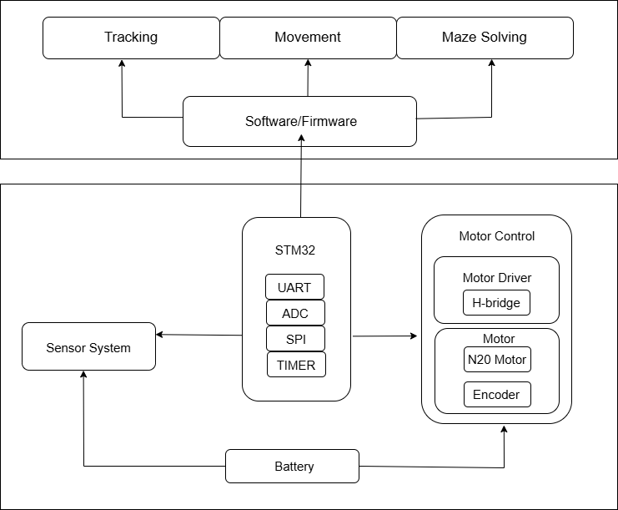
Figure 19. STM32 Controller Block Diagram

4. N20 Encoder Motor (500 RPM)

Logic:
- Motor Movement:
  - Converts electrical energy from the motor driver into rotational motion to drive the robot's wheels.

- Encoder Feedback:
  - Generates pulse signals as the motor rotates.
  - The microcontroller counts these pulses to calculate speed and position:
RPM = ( Pulses per Second) * 60 / Pulses per Revolution

  - Feedback helps maintain precise movements, such as:
    - Keeping a straight path.
    - Ensuring accurate 90° turns.

5.Testing Parameters and Procedures

Test Component | Testing Objective | Procedure | Expected Outcome
TOF Sensor Calibration | Ensure accurate wall detection | Test sensor at various distances from walls | Sensor correctly detects walls at specified distances
Motor Calibration | Verify motor response to PWM signals | Vary PWM duty cycle and observe motor speed | Motor speed adjusts smoothly and proportionally
Encoder Calibration | Verify accuracy of position tracking | Move robot a known distance and check encoder count | Encoder count matches expected values within tolerance
Algorithm Testing | Verify pathfinding algorithm efficiency | Test the algorithm in various maze configurations | Robot successfully solves the maze and reaches the center

9.Electronic connection block diagram.

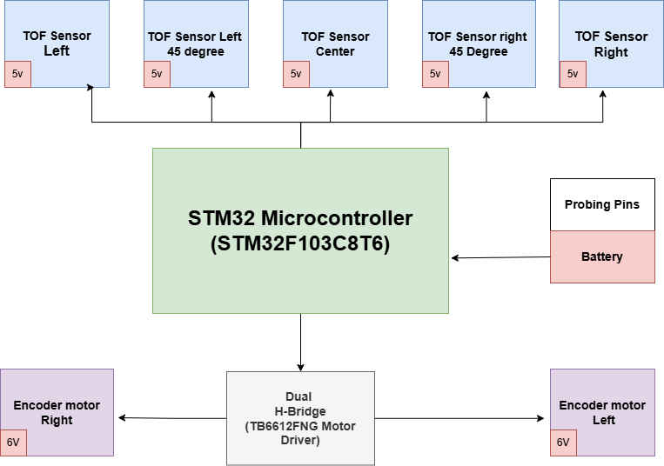
Figure 20. Bot Connection Block Diagram

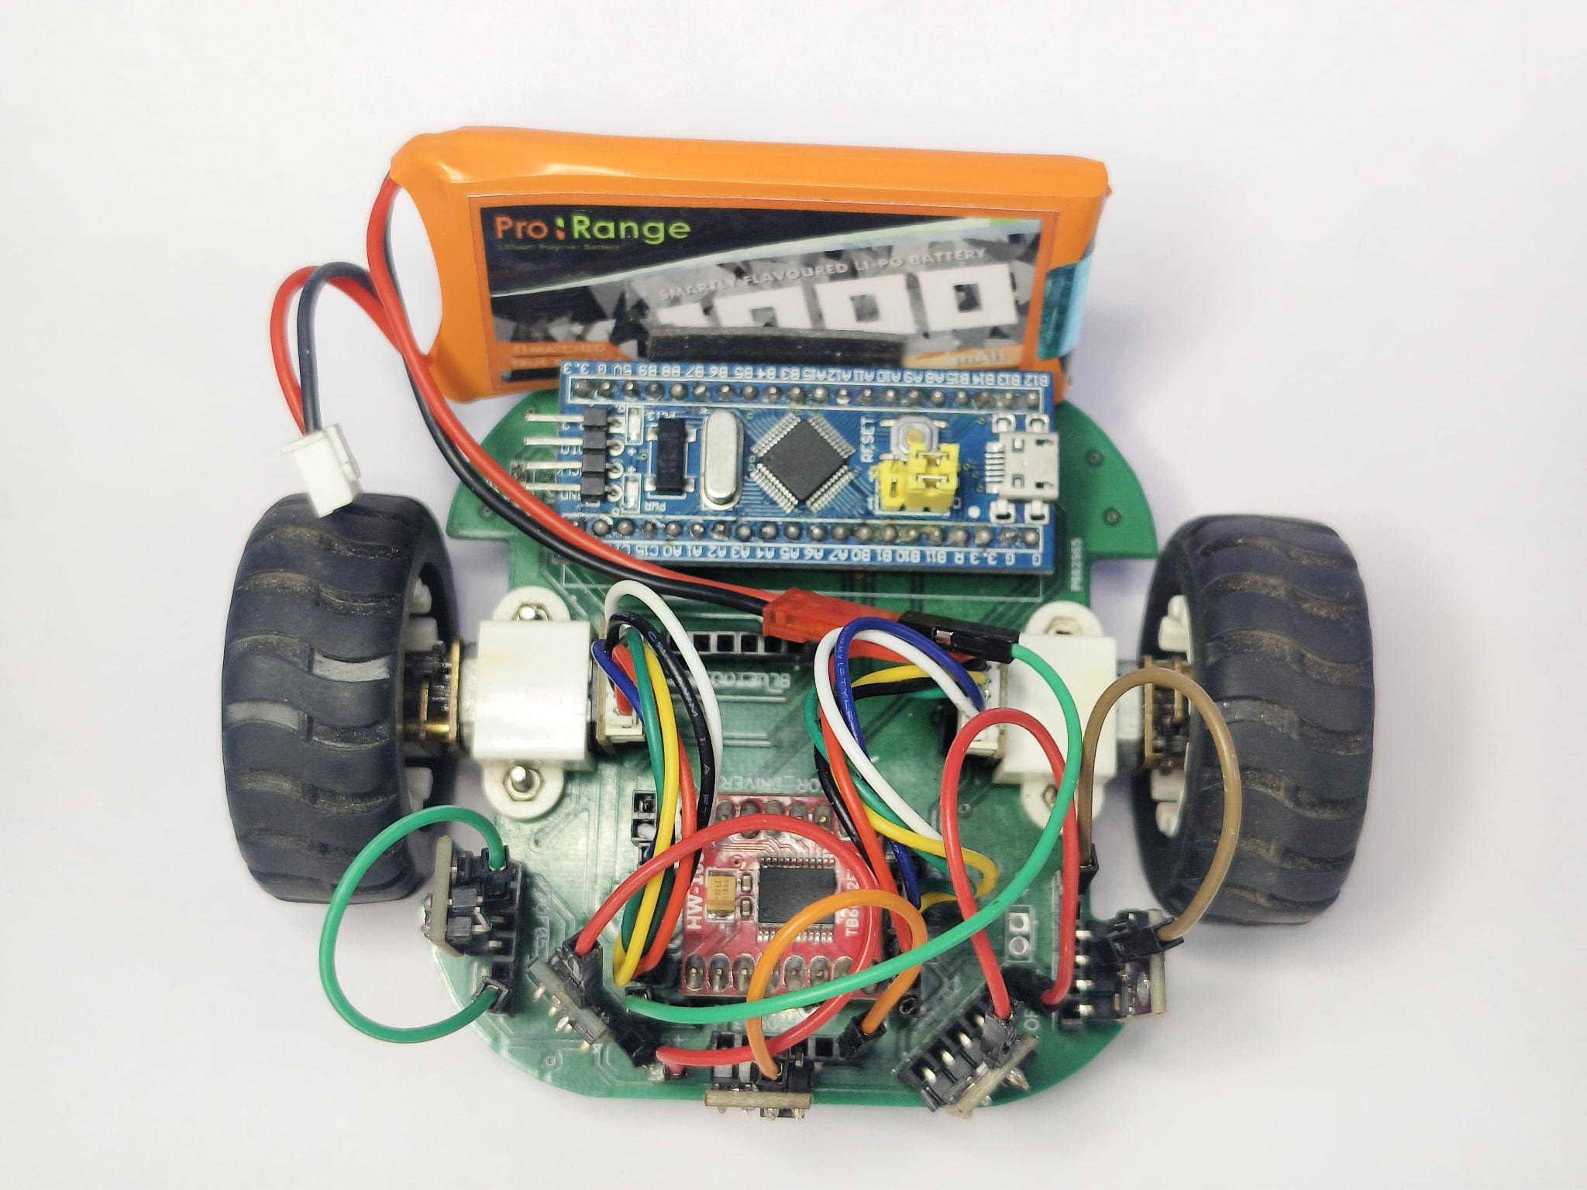
Figure 21. Final Bot Top View

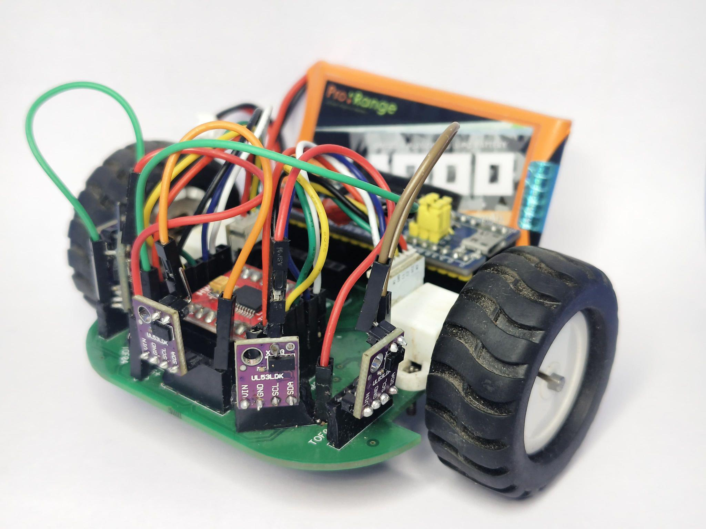
Figure 21. Final Bot Side View

10.Futuristic application of Robot as well as in commercialization.

Component | Specification | Initial Prototype | Final Prototype
IMAGE |  | 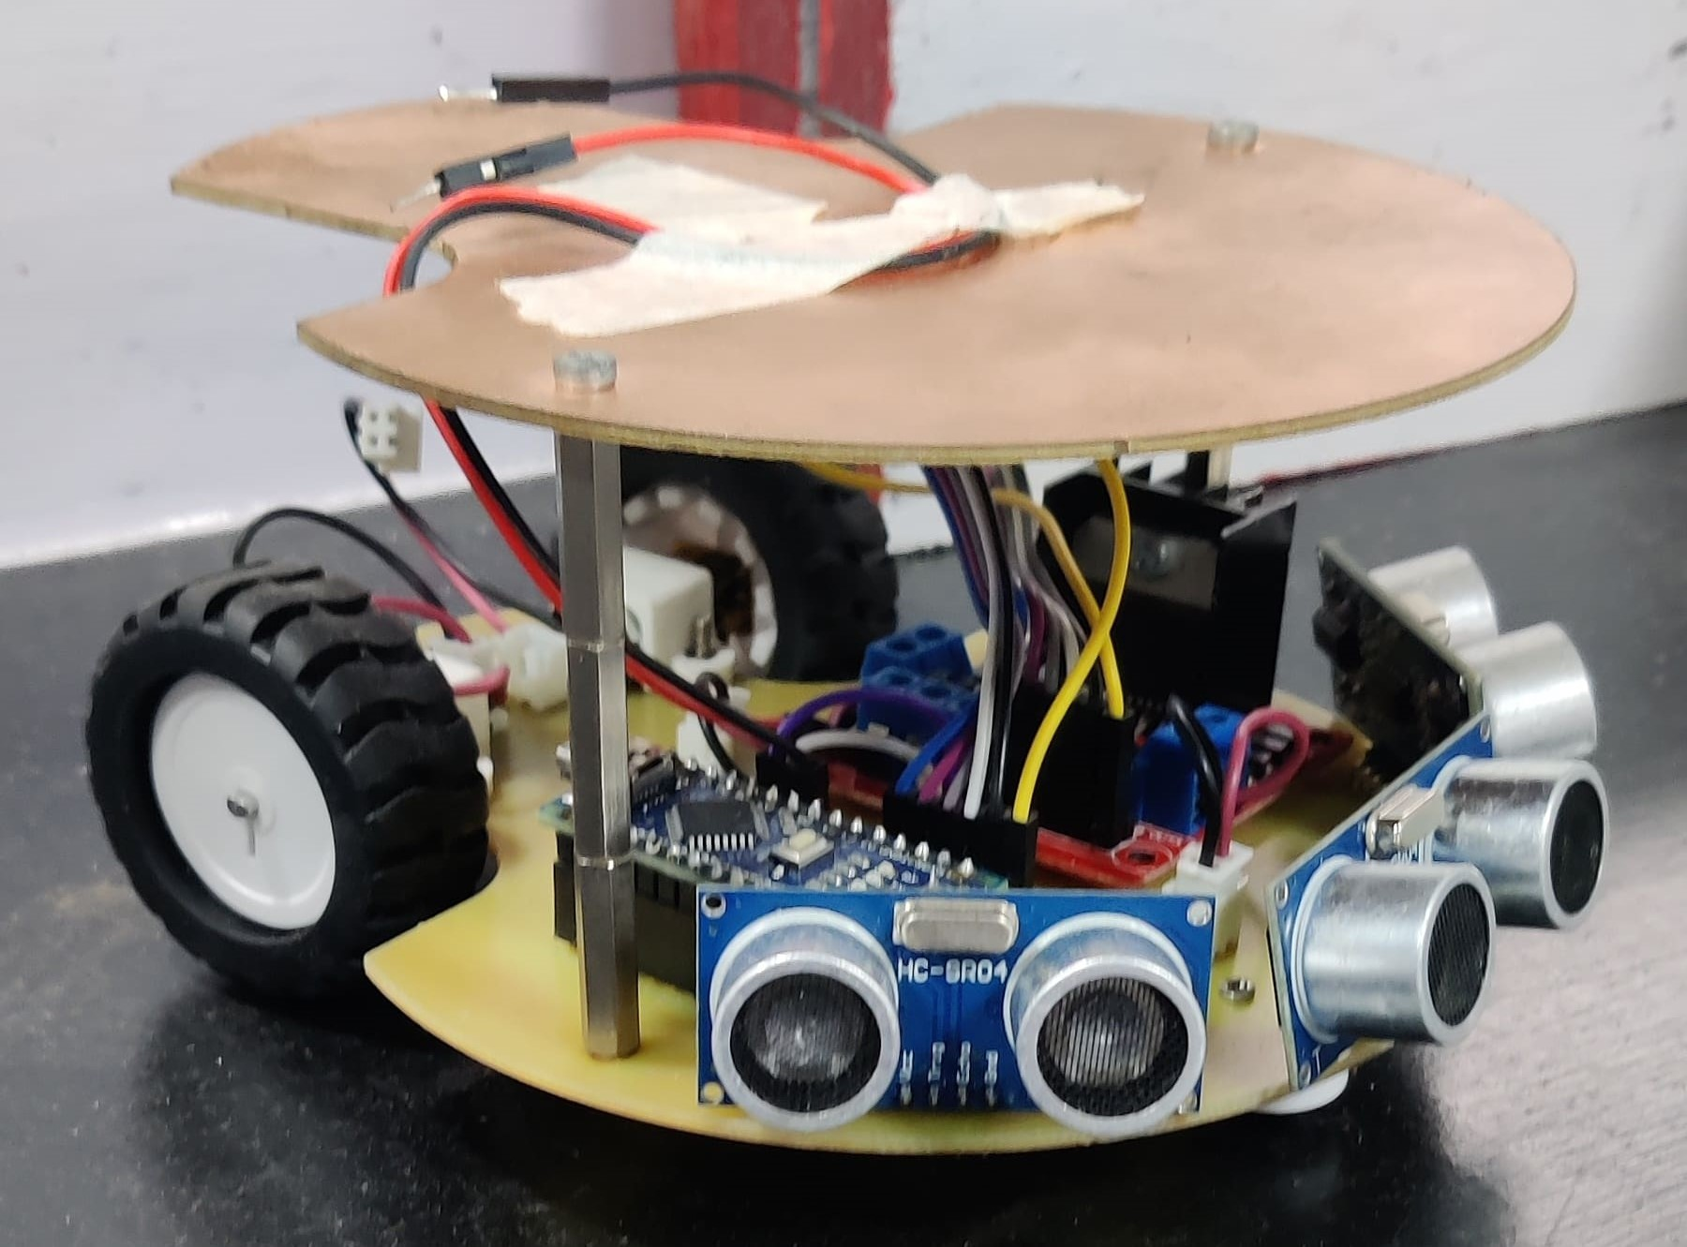 | 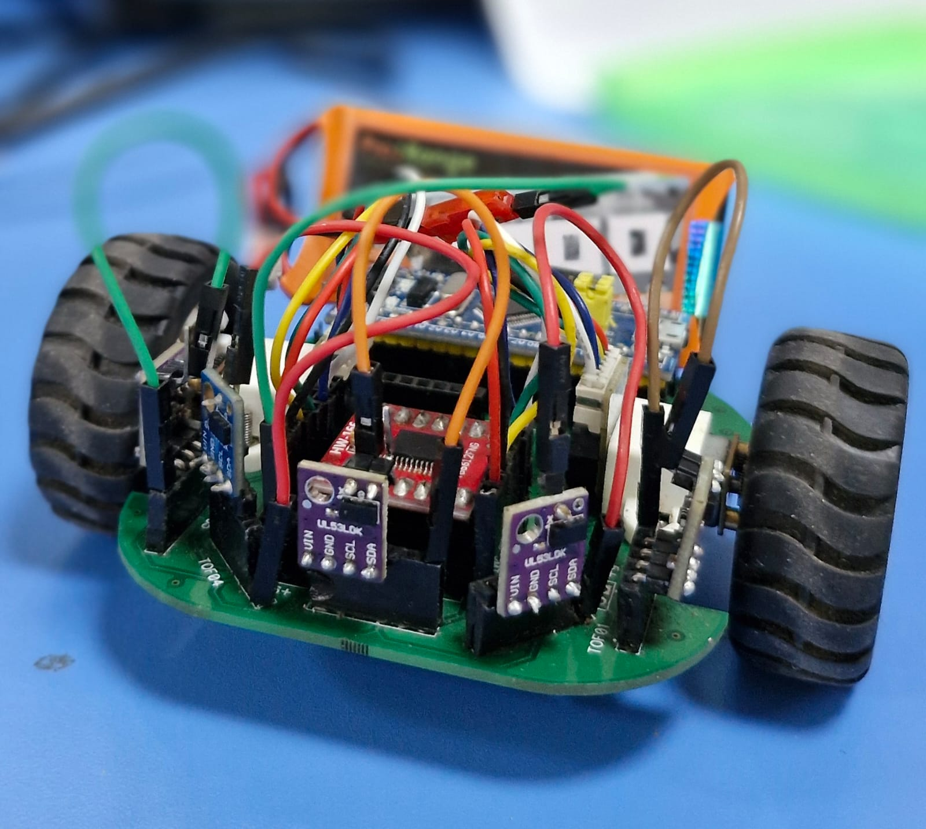
MOTOR DRIVER | NAME | L298N | TB6612FNG
 | VOLTAGE RANGE | 4.8V to 46V | 2.7V To 15V
 | CURRENT HANDLING | 2A - 3A | 1.2A - 3.2A
 | CONTROL INTERFACE | PWM & GPIO | PWM & GPIO
 | PROTECTION FEATURE | NIL | Overheat protection
 | H-BRIDGE CONFIGURATION | DUAL H-bridge | DUAL H-bridge
MICROCONTROLLER | NAME | ARDUINO NANO | STM32F103C8T6
 | PROCESSOR | ATMEGA328P | 32-BIT ARM CORTEX M3 CORE
 | CPU ARCHITECTURE | 8-BIT AVR architecture | 32-bit ARM CORTEX M3 CORE
 | CLOCK SPEED | 16 MHZ | UPTO 72 MHZ
 | FLASH MEMORY | 32 KB | 64 KB
 | RAM | 2KB of SRAM | 20 KB of SRAM
 | GPIO PINS | 22 PINS | 37 PINS
 | ANALOG INPUTS | 6 PINS | 10 or 16 PINS
 | OPERATING VOLTAGE | 5V | 3.3V
 | DEVELOPMENT ENVIRONMENT | ARDUINO IDE | ARDUINO IDE

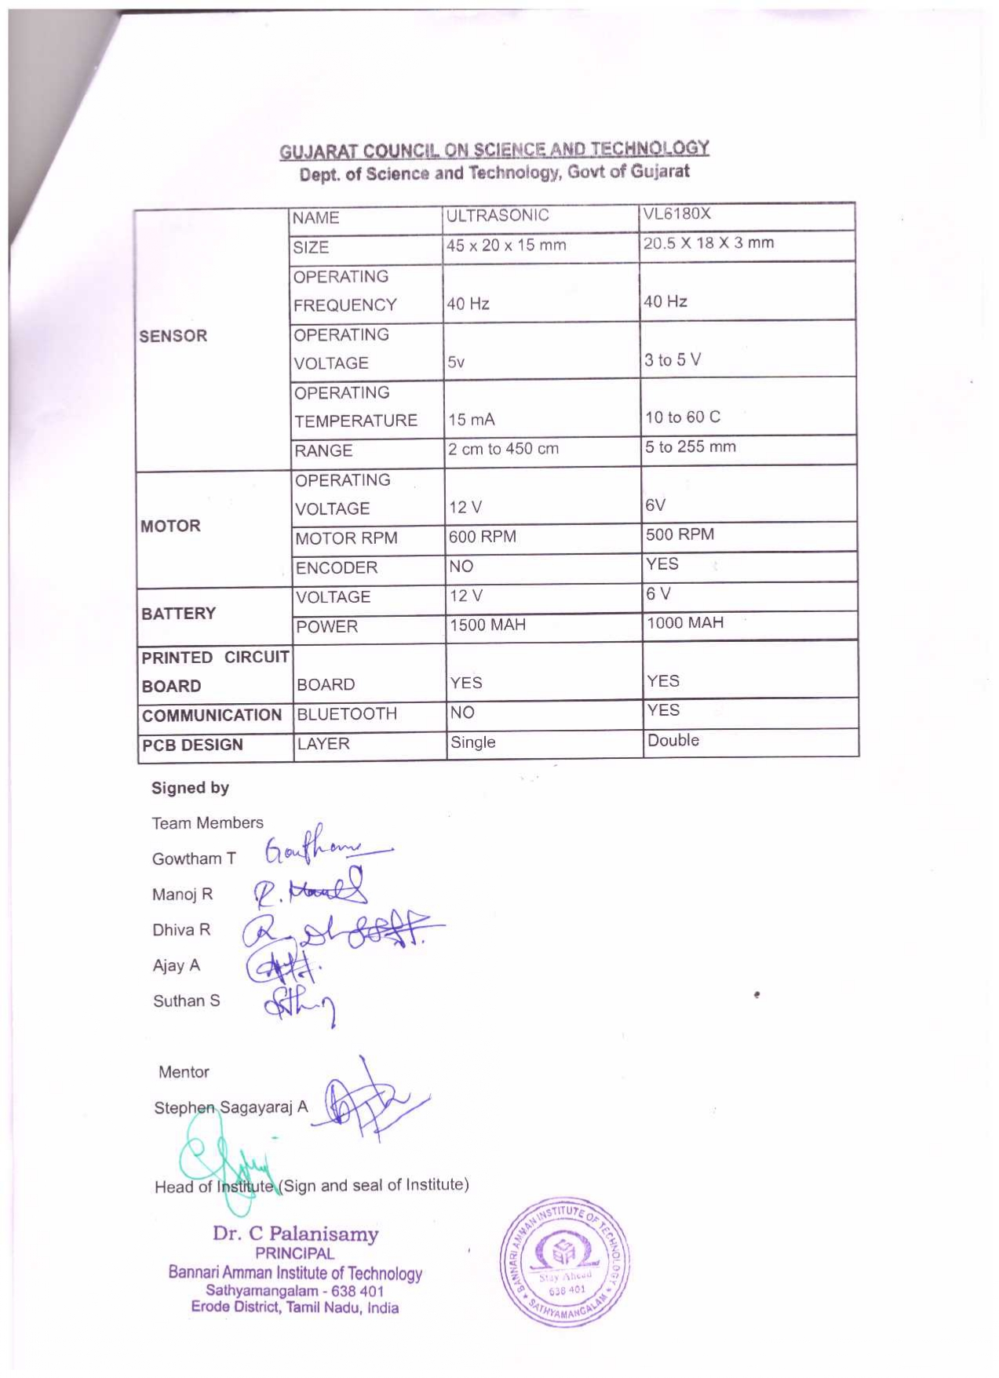

Enclosures (As an Appendix):
- Details and photographs of Mentor and Team Members
- Drive link or QR CODE (for technical report, video and photographs)
- Bank details of Institute
- Short Video of Robot-Making (starting to end) for 3 minutes (video limit upto 1 GB)
- Final prototype video of 1 minute (video limit upto 1 GB)
- Some good photographs of final design (5 photos)

*Hard copy of technical report to be sent to GUJCOST Office Address
To
Advisor & Member Secretary
Block B, 7th Floor, M. S. Building, Nr. Pathikashram, Sector 11, Gandhinagar-382011
- All enclosures should be in a pen drive and sent to GUJCOST Office
- Document to be uploaded in the Robofest website
- Mail at robofest4.0gujcost@gmail.com , rd.gujcost@gmail.com (cc)
Last date for submission: 10th January, 2025

